5th March 2015

Update for Stokeinteignhead Parish Council
Re: Flooding Issues and progress

Highway improvement works started the week commencing Monday 2nd March, to improve buddle holes in locations 3 and 4 marked on the plan below. Locations 1 and 2 have not been progressed as the land owner concerned required further works and measures to avoid increased surface water and silts on the land. Any measures to consider here could be costly and so should be developed in conjunction with the main scheme.

Our consultant engineer, Nigel Smith has started work to build upon Robin Selby’s report and to develop a more detailed survey of the area on which the main scheme design can be based.

To date, Nigel has:
- Reviewed Robin’s report and the existing CCTV and channel surveys;
- Attended the site to check flow routes from gates/fields and further hydraulic analysis (partially complete);
- Completed a level and dimension survey of the green lane adjacent to Stoke Road for the proposed silt trap;
- Started to build the hydraulic model to determine the current drainage system capacity and the effect of upsizing any limiting structures;
- Nigel is yet to meet with Fred Corns of the Parish Flood Group but is likely to arrange this within the next week.
- Draft report with recommendations is yet to be completed.
Stilt Trap at Village Hall:
The proposed silt trap is now with DCC at the detailed design stage, anticipating going to contractors in March/April.
Robin Selby will be producing a management plan that the Parish can use or adapt to manage the maintenance of the silt trap once it is installed.
Funding:
The Devon Local Flood Risk Management Strategy Action Plan is to go to DCC Cabinet for approval this month. This plan includes the allocation of funding for Stokeinteignhead for the financial year April 2015 – March 2016 which will help to continue to progress the study and Main Scheme.

See below: Updated Stokeinteignhead Action Plan 2015/2016 and drainage improvement locations.

Jessica Bott
Senior Flood Risk Officer
Devon County Council Flood Risk Management

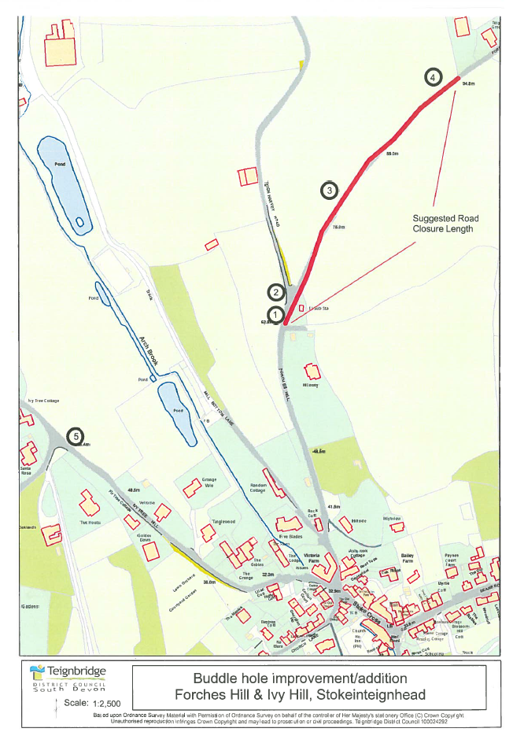
Plan of drainage improvement locations.

Stokeinteignhead Action Plan 2015/2016
Action | 2015 |  |  |  |  |  |  |  |  |  |  |  | 2016
Action | Jan | Feb | Mar | Apr | May | Jun | Jul | Aug | Sep | Oct | Nov | Dec | Jan | Feb | Mar
Silt trap:
- Survey and design
- Procure and construct
- Maintenance schedule to be agreed by Parish
- Highway agreement/ownership notice etc.
Obtain LiDAR/topographic data for further work
Engineer to meet with Flood Group re: village drainage plan
Community Pathfinder Project to liaise with Parish
Hydraulic modelling
Optioneering
Preferred option
Costing
Production of Project Appraisal Report (PAR)
Environmental report/statement:
- Outline further investigations necessary
Outline design for PAR
Submit PAR
Detailed design of preferred option
Serve any relevant notices
Procurement
Tender review
Construction phase
Parish Council/residents comms and updates

Not completed
In progress
Completed

